**KitchenSync - User Manual**

Thank you for choosing to use KitchenSync Application.

## **Contents**

1. General overview
2. Login/Signup
   1. Signing up for the Application
   2. Logging In to Application
3. Home Page
4. Using the application
   1. Managing your Inventory
   2. Your Inventory List.
5. Predict Dish
   1. Selecting the image
   2. Choosing an image from the gallery
   3. Getting the nutritional value
6. Contact information.
7. **General Overview:**

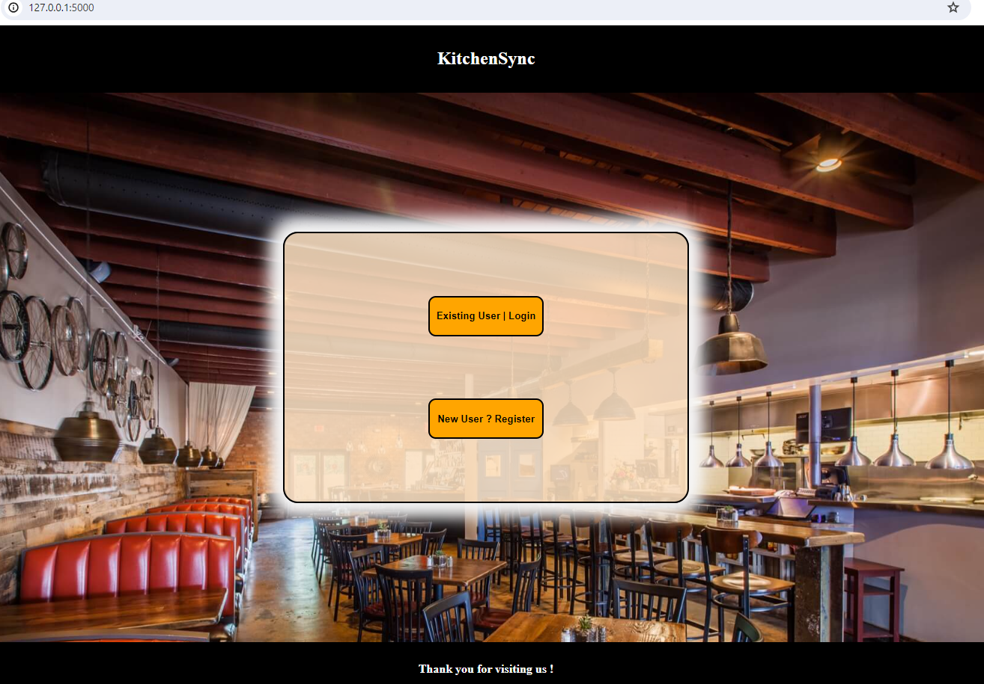

KitchenSync is an Interactive web application for identifying food names based on the images, providing nutritional facts (For Example: calculating calories of the food you are eating) for diet advice and predicting the recipes based on the predicted food names. It streamlines pantry management and meal planning seamlessly.

**2. Login/Signup**

**2.1 Signing up to the Application.**

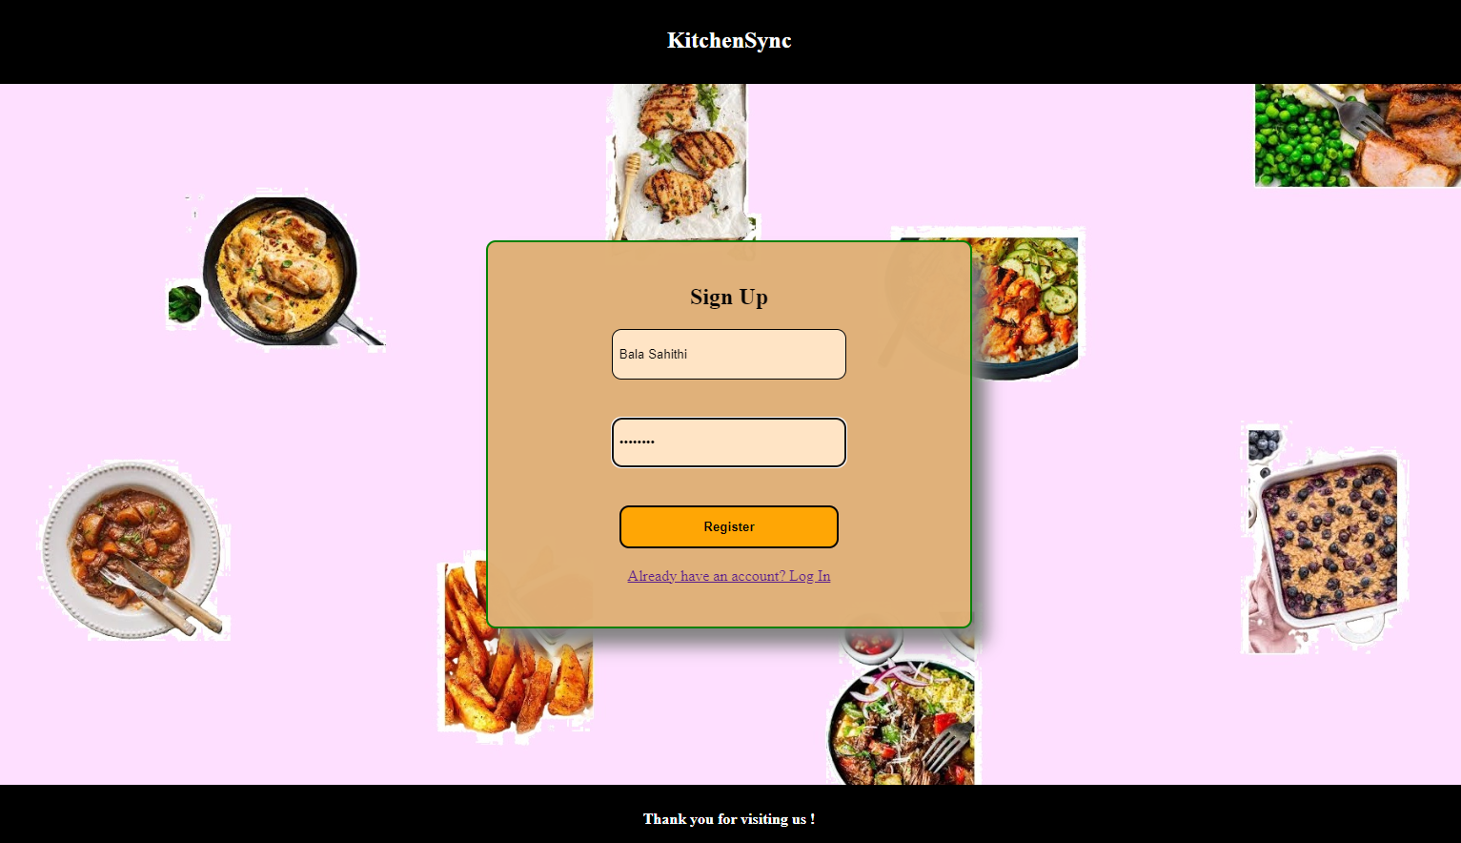

New user needs to sign up for first time by giving his/her username and password. After clicking on Register button, it will redirect to the sign-in page or Login page.

**2.1 Logging into Application**

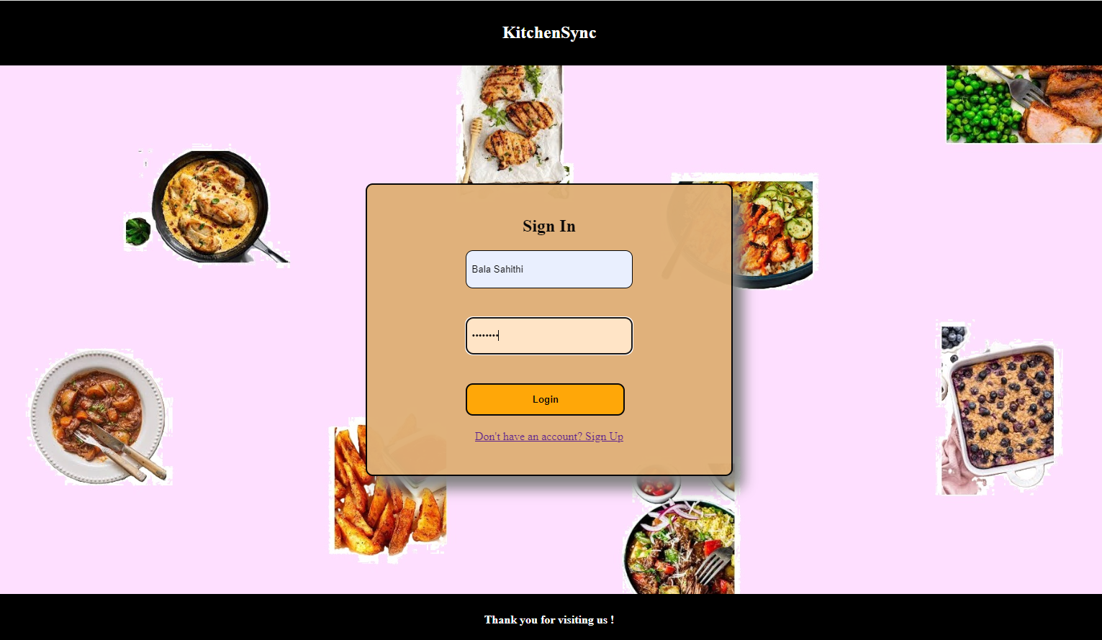

When user clicks on Sign In page, he/she needs to give their respective username and password, then hit on Login button. It will be redirected to our application’s home page.

**3. Home Page**

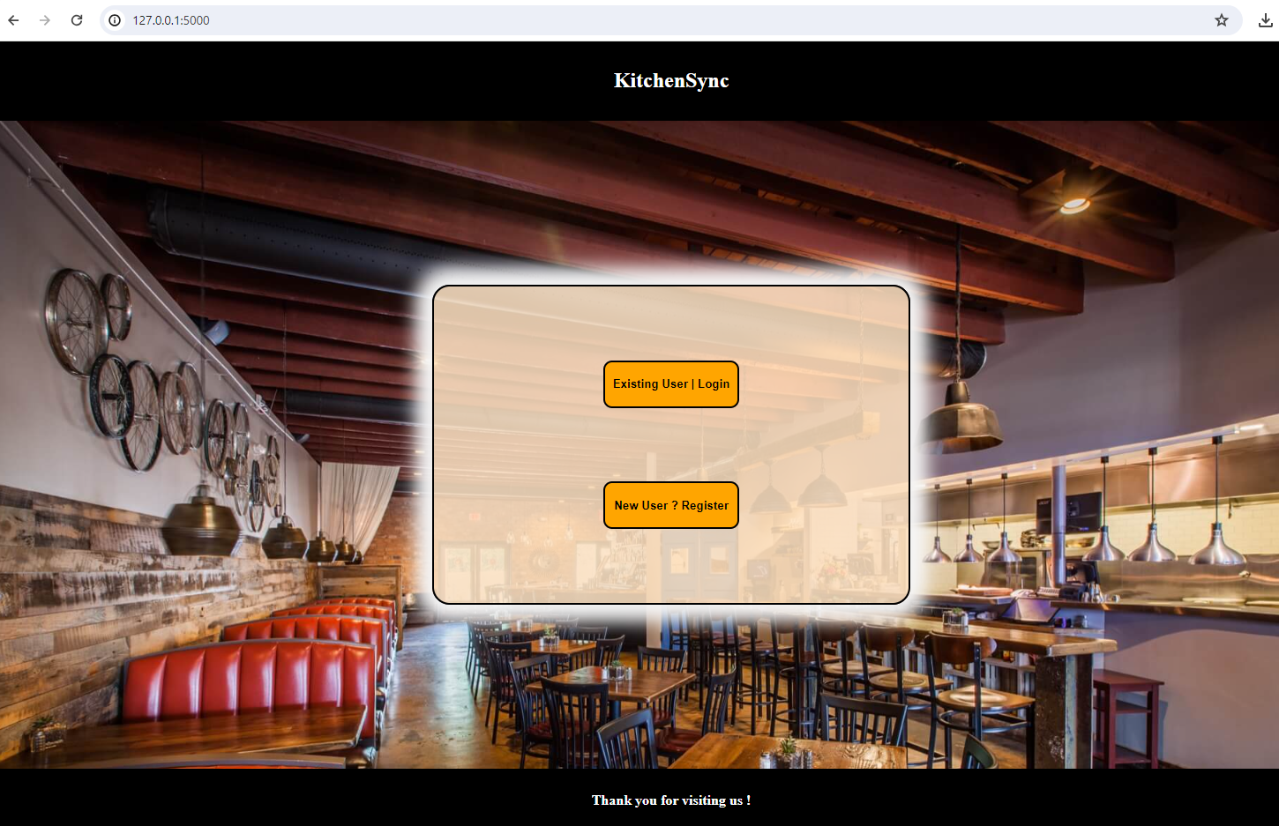

This is what our web application home page looks like. After successful login, user is redirected to our inventory page “Manage Your Inventory”.

**4. Using the Application**

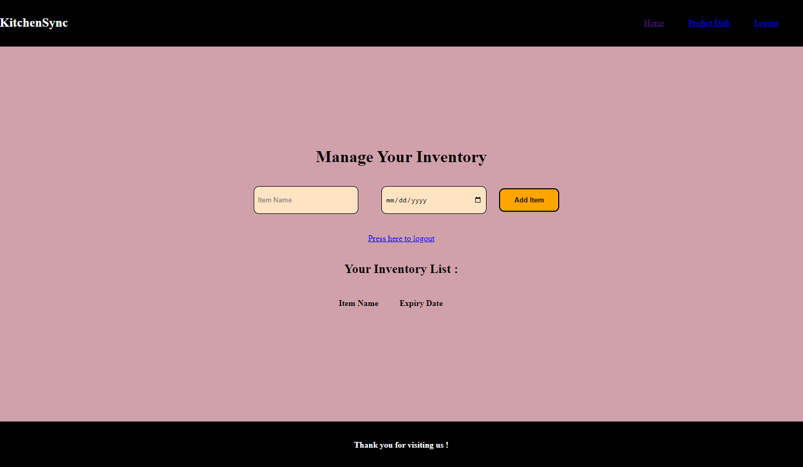

The above screen is our Inventory page where user can add their item name and expiry date and then click on Add Item button. In the top right corner, user can see “Home”, “Predict Dish” and “Logout” Buttons. The added items are stored in Inventory List.

**4.1 Managing Your Inventory**

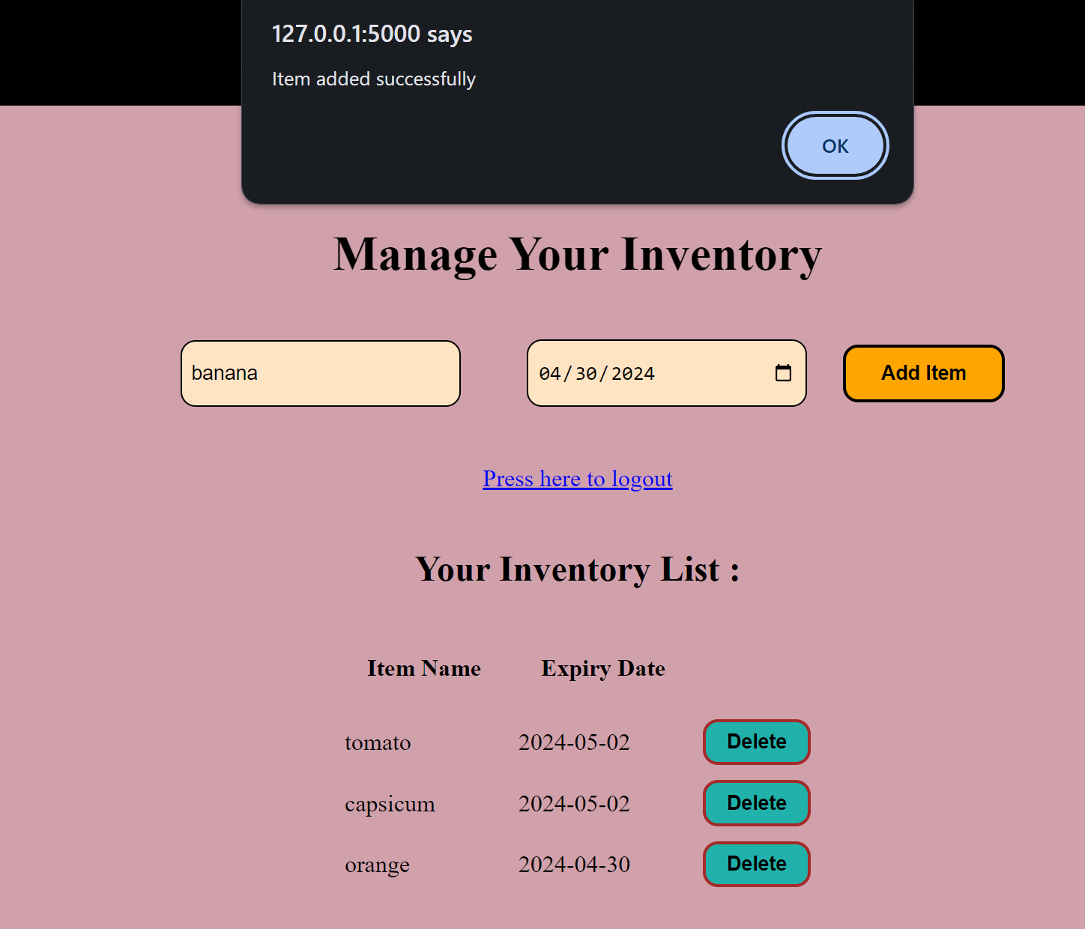

Inventory List looks like this, user can see their items and the item’s expiry dates.

**4.2 Your Inventory list**

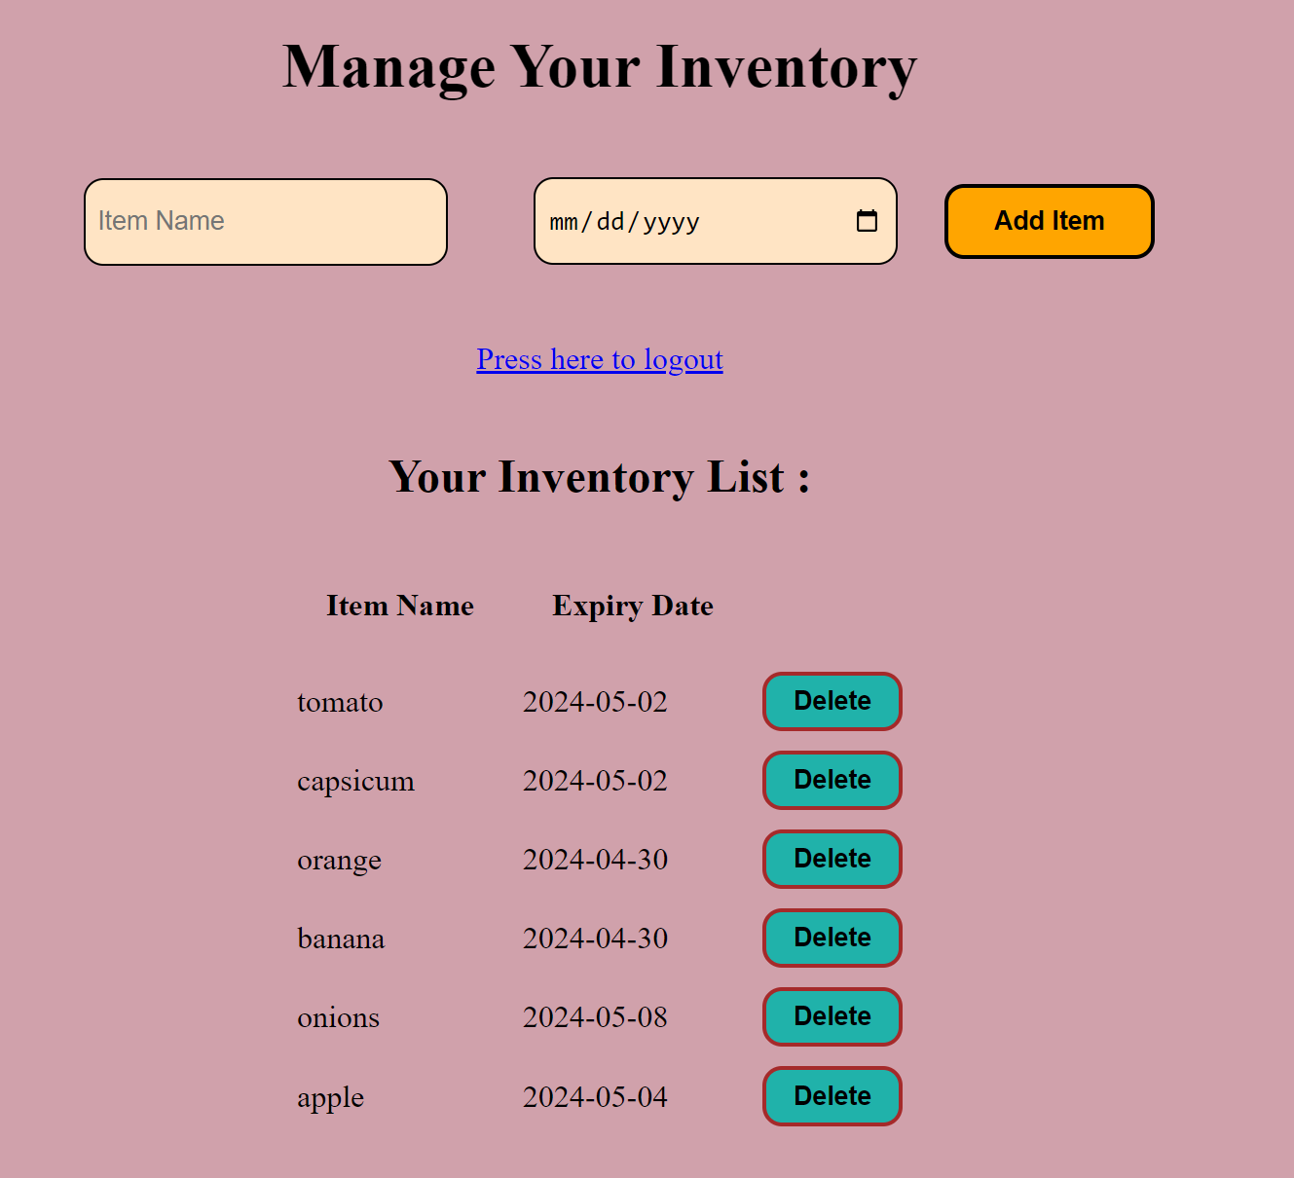

Inventory List has 2 columns, Item Name, and Expiry Date, Added items are stored in those columns.

**5. Predict Dish**

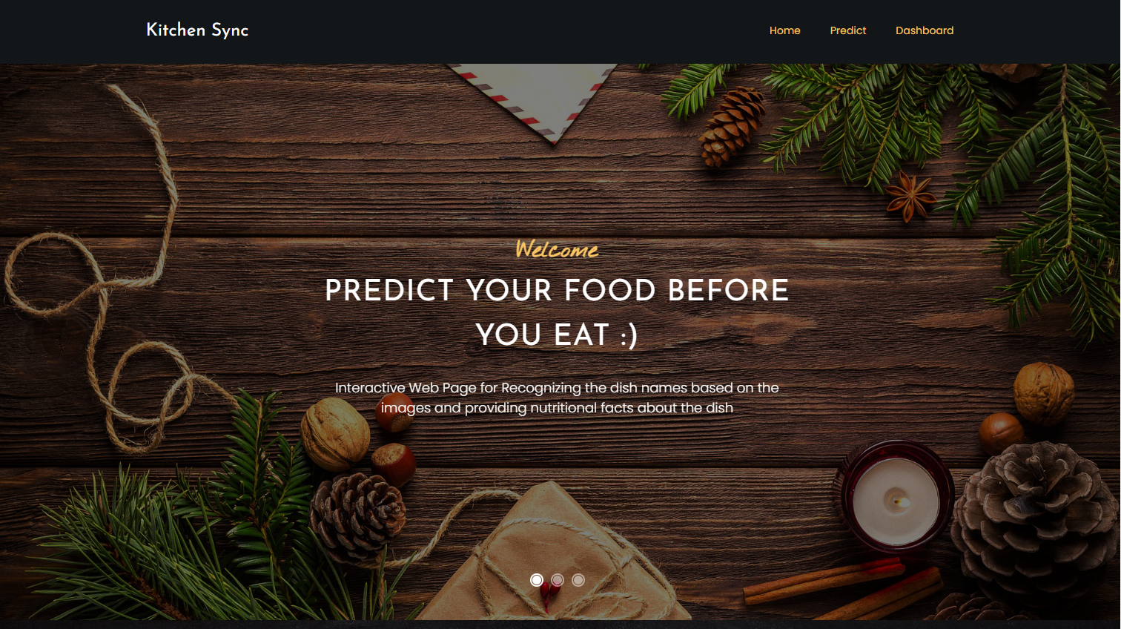

Our KitchenSync application provides one more feature i.e, Predict Dish. When the user clicks on Predict Dish, it will be redirected to this page. It predicts/detects the item, which user uploaded.

**5.1 Selecting the image**

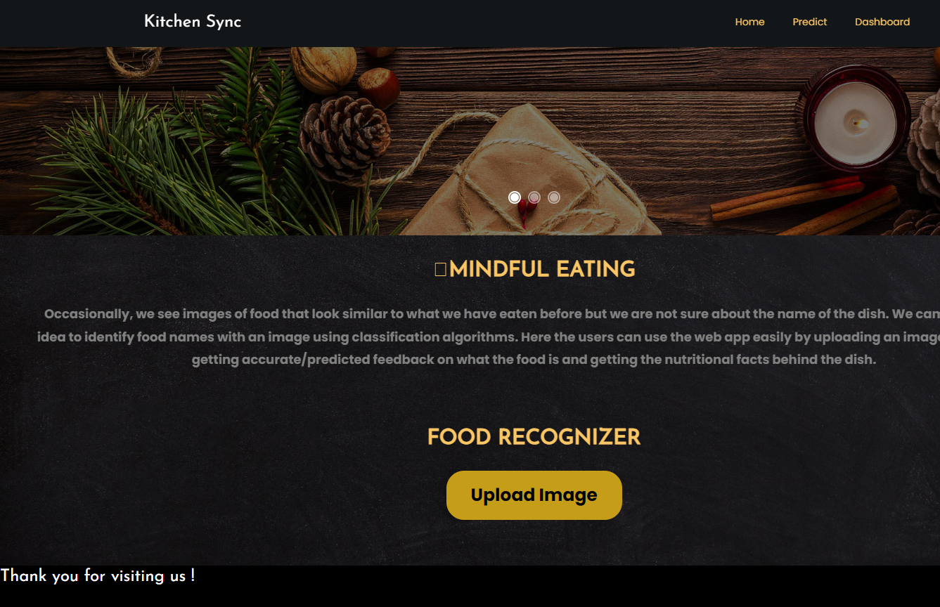

For predicting a dish, user needs to upload an image from their local machine. The above page shows the same.

**5.2 Choosing the image from gallery**

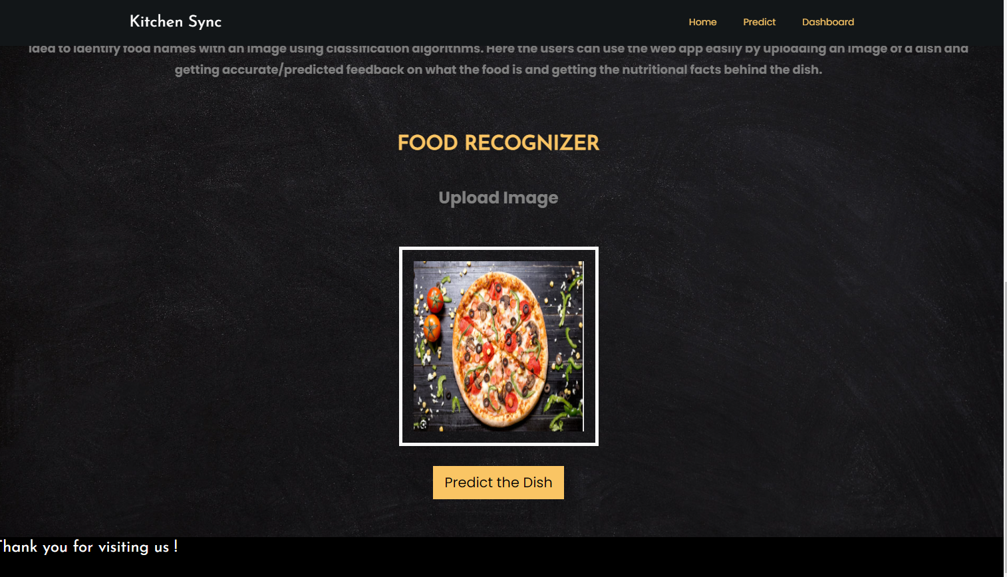

Here we can take this image for Predict the Dish, we can upload it through our local machine.

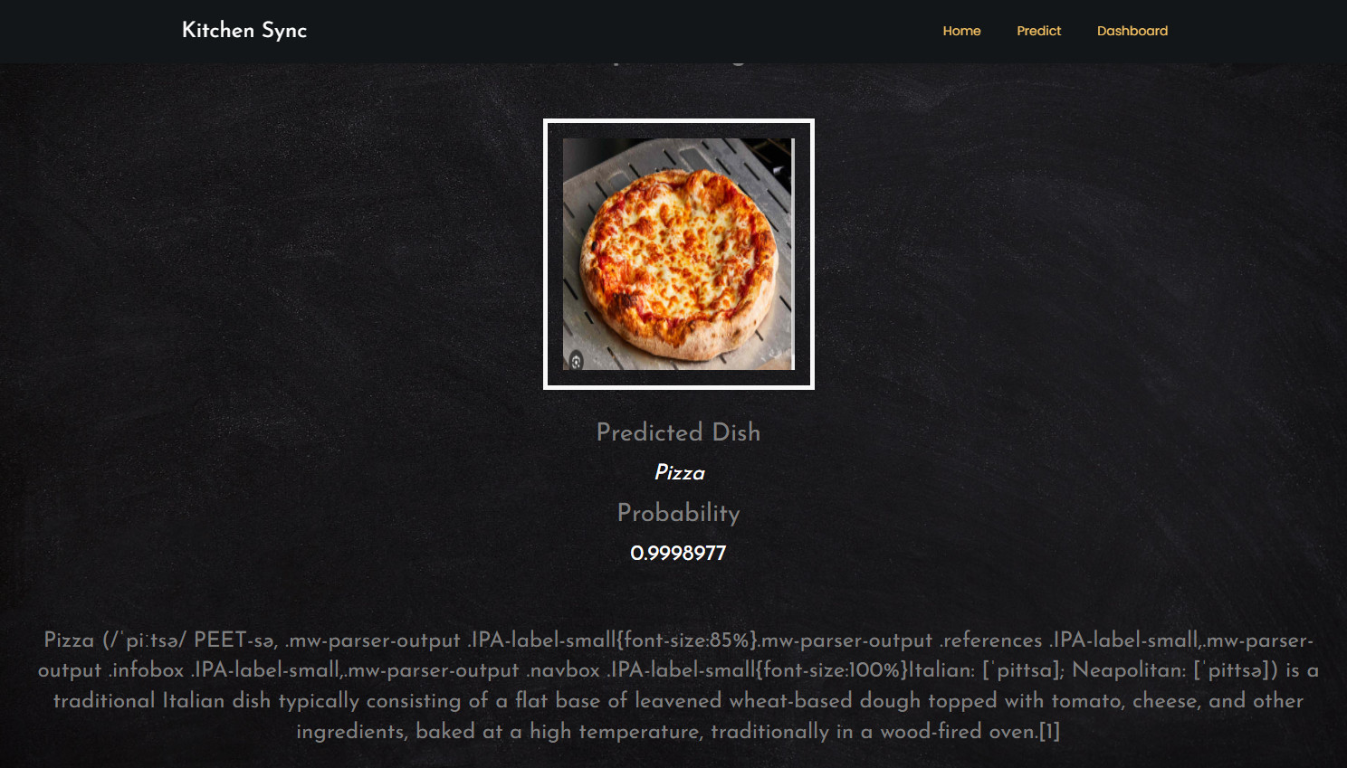

Our KitchenSync web application predicted the food image we uploaded correctly. It gave the analysis of the food item also. The results are shown in the above image.

**5.3 Getting the Nutritional value.**

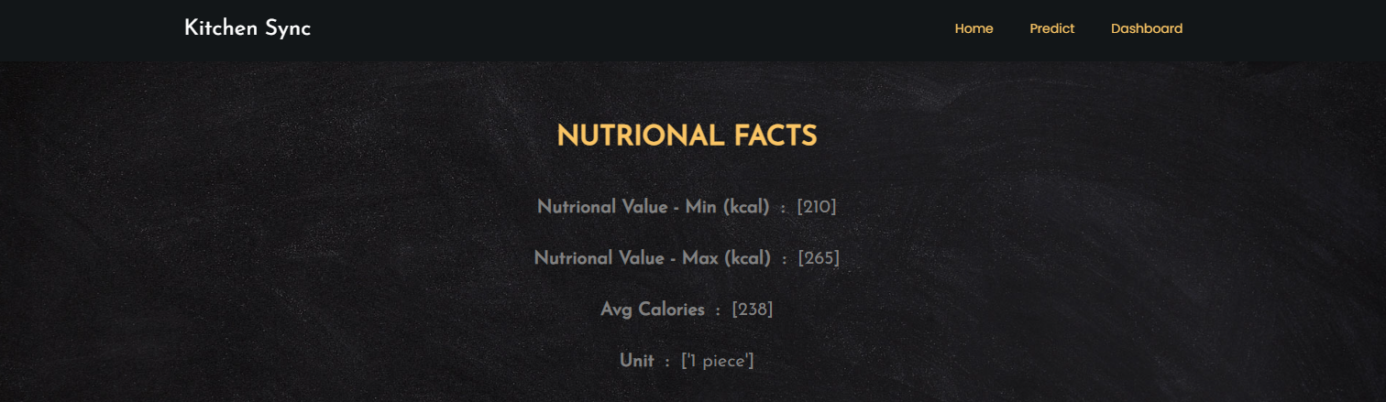

Also, it gives the Nutritional facts of the uploaded image like above. So that users can monitor their Nutritional facts accordingly.

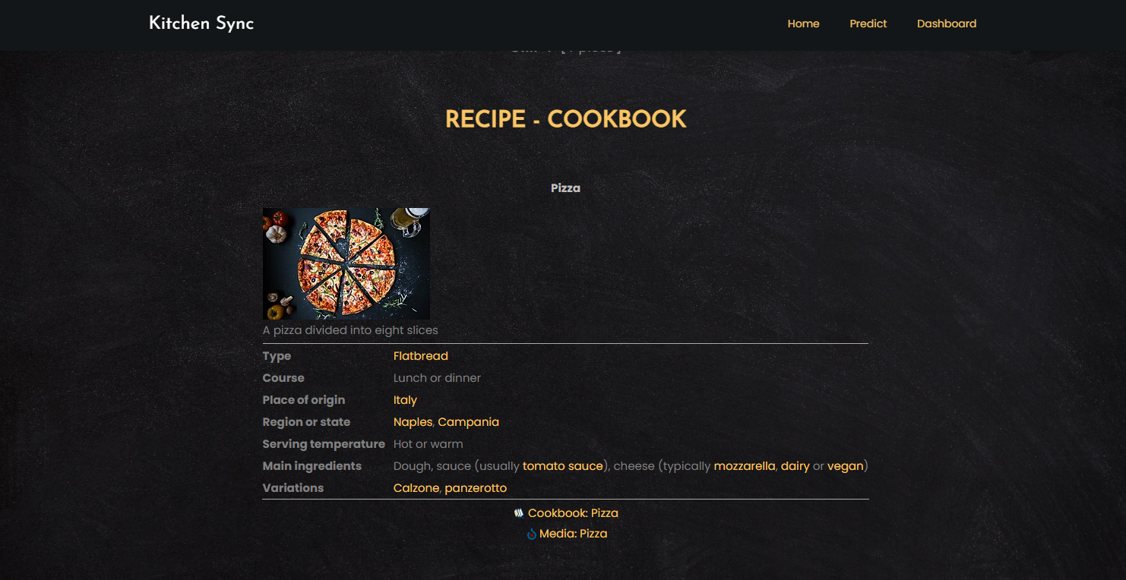

Also user gets the Receipe CookBook for the food item. This feature is beneficial for new users who wants to start their cooking.

**6. Logout**

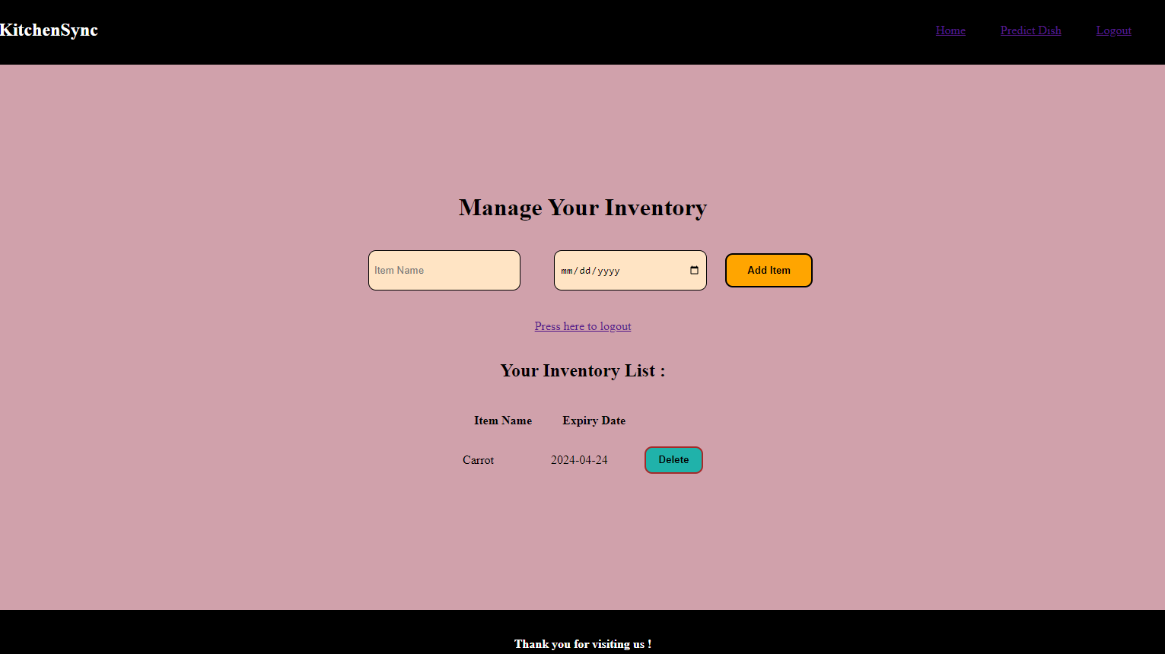

If user wants to exit our application, then click on “**Press here to Logout**”, he/she will be exit out of our application.